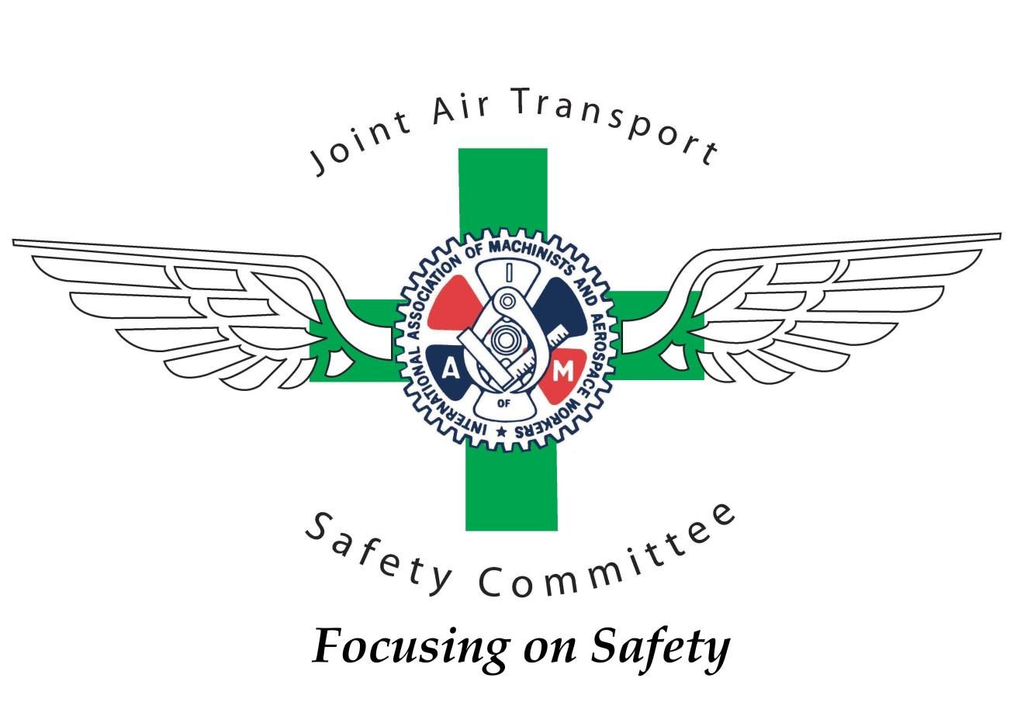

2017 IAM Transportation Conference

JATSC Report

Good morning brothers and sisters, my name is Bill Salo and it is my privilege to represent the members of the Joint Air Transport Safety Committee to present this report. We believe that safety is one of the most important aspects of everyone’s work environment.

For those that don’t know, the committee is made up of the Safety Leadership from each one of the Air Transport District Lodges 140, 141 and 142. It also includes TWU safety representatives from our IAM-TWU Association as well as representatives from the Grand Lodge. Collectively, the committee represents over 500 years of front line aviation experience and we come from a broad spectrum of airlines, geographical locations and work groups within the airline and related industries.

We would like to take this opportunity to thank Sito Pantoja, Joe Tiberi, Tim Klima and Shawn Humphries for their guidance, leadership and support. We would also like to thank the leadership of Districts 140, 141, 142 and the TWU for their support of each of the committee members.

Our Mission, simply put, is to ensure that every IAM member goes home each and every day from work to their family and loved ones. We do this in a variety of ways, mainly through the development and support of local Ground Safety Committees.

We are a resource to governmental agencies and we provide support to our negotiating committees for strong safety and health contract language.

We meet face to face once a quarter and through conference calls each month to collaborate and coordinate our individual District safety efforts and to collectively provide safety leadership and develop initiatives that support our overall mission.

In September of 2015, the JATSC was recognized by the National Safety Council with the “Award of Honor for Exemplary Service to Safety” for our work on behalf of our members. The presentation plaque is proudly on display at the William W. Winpisinger Education and Technology Center.

As I stated earlier, the JATSC meets quarterly to review safety issues at all of the represented company’s. Since the 2015 Transportation Conference in Fort Lauderdale, we have met in Chicago, Las Vegas, St Louis, Phoenix and Seattle. We also held our annual JATSC Safety Conference in June of 2016 at the WWW 3 Center.

The Local Lodge Ground Safety and Health Committees are at the heart of protecting our members on a daily basis and we have developed a tri-fold flyer to help get new and perspective Ground Safety Committee members started off on the right foot. If you need flyers let a JATSC member know and they will assist in providing them.

The JATSC continues to present the “Safety 101” course for Safety Committees. We have the course workbook on a thumb drive and a DVD is available to help get the information out to those Safety Committees that we have not been able to visit yet. If you would like members of the JATSC come to your Local to work with your Local Lodge Ground Safety Committee, please ask a member of the JATSC.

The JATSC also has a website at www.iamairsafety.org that we encourage members to visit it for more information on safety related issues.

It is important to recognize individuals in Ground and Flight Safety within the airline industry that have performed an extra-exemplary act of safety or have made a significant long term contribution to the safety and health of IAM members. We do this by presenting the IAM Transportation “Excellence in Safety” Award. This award is presented when merit warrants and nominations may be submitted by IAM members in good standing from DL 140, 141, or 142. Please remember to nominate someone when you are aware of an extra- exemplary act of safety.

A highlight of each year is the Joint Ground Safety Training Conference held at the William W. Winpisinger Education and Technology Center.

In June 2016, the JATSC hosted a large group of safety participants for three days of safety and health training.
Our group includes IAM and TWU safety reps, also included are management safety reps and guests.

We always have a full house at the center which is great for the membership to have fellow members that are willing to learn so they can help protect other members while on or off the job.

We had a full agenda for the three days which included information on Active Shooter, Ergonomics, Accident Investigation, Conflict Resolution, Just Culture, Generational Diversity and Emergency Evacuation. We also had breakout sessions for the U.S. and Canadian workers for the differences that the members might have.
This was a great conference for learning, networking and growing safety friendships.

With that being said, we have an even greater conference schedule for this year. The last week of August will be the 2017 Ground Safety Training Conference. The Theme this year is Safety – Working Together for Success and we will have guest speakers and panel discussions that will show just how successful we can be when working together. We will start on August 28 and spend three full days working and learning together. Our goal is to have at least one member from every Local Lodge attend the conference, so be sure and register early as we usually have a stand-by list each year.

As you can see, the JATSC had a busy year and we are looking forward to another successful year.

When you get back home, take a few minutes to encourage and thank your Local Safety Committee. This can sometimes be a thankless job and we need to remind them that their work is vital to our members and that we appreciate their efforts. Please continue to support them.

Let us know how we can help you develop strong and effective Safety Committees.

Thanks for your support and Stay Safe!

